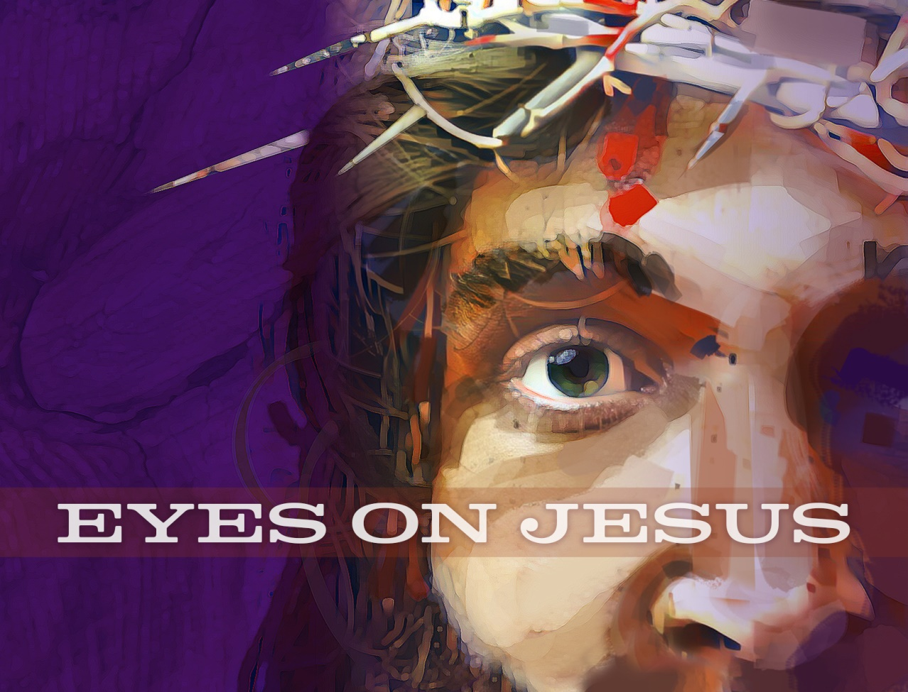

Lent 2
Midweek Worship
Sleepy Eyes

CHRIST LUTHERAN CHURCH | Lodi, California
EVENING PRAYER (CW page 52)
Opening Hymn Rise, My Soul, to Watch and Pray |CW 472

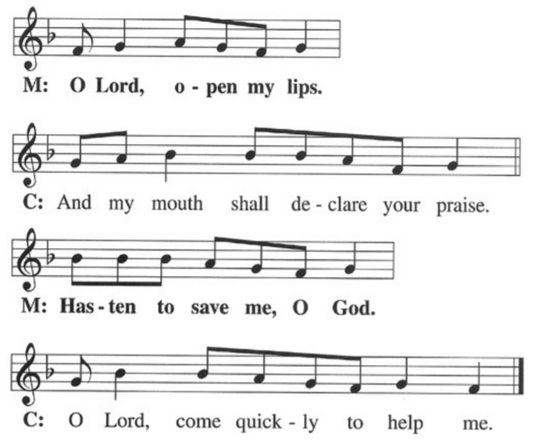
M: Lord God, you have brought us safely to this hour of evening prayer. We thank you for providing all that we need for body and life. Bless us who have gathered in your name. Forgive our sins. Speak to our hearts. Dispel our sorrows with the comfort of your Word, and receive our hymns of thanks and praise, through Jesus Christ, our living Savior, who reigns with you and the Holy Spirit, one God, now and forever.
C: Amen.
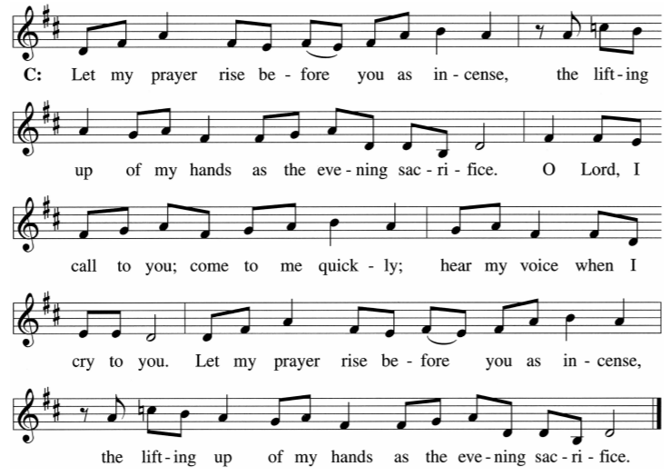
THE WORD
PSALM OF THE DAY Psalm 121
The psalmist is confident that the Lord will always watch over him
M: Indeed, the Protector of Israel
does not slumber or sleep
C: I lift my eyes toward the mountains.
Where will my help come from?
My help comes from the Lord,
the Maker of heaven and earth.
M: He will not allow your foot to slip;
your Protector will not slumber.
C: Indeed, the Protector of Israel
does not slumber or sleep.
M: The Lord protects you;
the Lord is a shelter right by your side.[
C: The sun will not strike you by day
or the moon by night.
M: The Lord will protect you from all harm;
he will protect your life.
C: The Lord will protect your coming and going
both now and forever.
M: Indeed, the Protector of Israel
does not slumber or sleep
Silence for meditation
Hymn Go to Dark Gethsemane | CW 104
LESSON Romans 13:8-14
Paul instructs us to wake up from our sleep, put off the deeds of darkness, and walk in the light.
⁸ Do not owe anyone anything, except to love one another, for the one who loves another has fulfilled the law. ⁹ The commandments, Do not commit adultery; do not murder; do not steal;^{[a]} do not covet;^{[b]} and any other commandment, are summed up by this commandment: Love your neighbor as yourself.^{[c]} ¹⁰ Love does no wrong to a neighbor. Love, therefore, is the fulfillment of the law.
¹¹ Besides this, since you know the time, it is already the hour for you^{[d]} to wake up from sleep, because now our salvation is nearer than when we first believed. ¹² The night is nearly over, and the day is near; so let us discard the deeds of darkness and put on the armor of light. ¹³ Let us walk with decency, as in the daytime: not in carousing and drunkenness; not in sexual impurity and promiscuity; not in quarreling and jealousy. ¹⁴ But put on the Lord Jesus Christ, and make no provision for the flesh to gratify its desires.
M: O Lord, have mercy on us.
C: Thanks be to God.

LESSON Mark 13:32-37
Why stay awake? Because the times is short and no one knows when Jesus will return.
³² “Now concerning that day or hour no one knows—neither the angels in heaven nor the Son —but only the Father.
³³ “Watch! Be alert!^{[a]} For you don’t know when the time is coming.
³⁴ “It is like a man on a journey, who left his house, gave authority to his servants, gave each one his work, and commanded the doorkeeper to be alert. ³⁵ Therefore be alert, since you don’t know when the master of the house is coming—whether in the evening or at midnight or at the crowing of the rooster or early in the morning. ³⁶ Otherwise, when he comes suddenly he might find you sleeping. ³⁷ And what I say to you, I say to everyone: Be alert!”
M: O Lord, have mercy on us.
C: Thanks be to God.

PASSION READING Mark 14:32-42
This Lent, we are looking at the events of our Lord’s Passion through the eyes of some of the people who witnessed it. The three disciples near Jesus in Gethsemane slept as Jesus prayed. And we are speechless today as our Lord awakens us to His Father’s will for Himself.

³² Then they came to a place named Gethsemane, and he told his disciples, “Sit here while I pray.” ³³ He took Peter, James, and John with him, and he began to be deeply distressed and troubled. ³⁴ He said to them, “I am deeply grieved^{[a]} to the point of death. Remain here and stay awake.” ³⁵ He went a little farther, fell to the ground, and prayed that if it were possible, the hour might pass from him. ³⁶ And he said, “Abba,^{[b]} Father! All things are possible for you. Take this cup away from me. Nevertheless, not what I will, but what you will.” ³⁷ Then he came and found them sleeping. He said to Peter, “Simon, are you sleeping? Couldn’t you stay awake one hour? ³⁸ Stay awake and pray so that you won’t enter into temptation.^{[c]} The spirit is willing, but the flesh is weak.” ³⁹ Once again he went away and prayed, saying the same thing. ⁴⁰ And again he came and found them sleeping, because they could not keep their eyes open. They did not know what to say to him. ⁴¹ Then he came a third time and said to them, “Are you still sleeping and resting? Enough! The time has come. See, the Son of Man is betrayed into the hands of sinners. ⁴² Get up; let’s go. See, my betrayer is near.”
M: O Lord, have mercy on us.
C: Thanks be to God.

DEVOTION Mark 14:32-42
Betraying Eyes

HYMN Chris, the Life of All the Living | CW 114 (vs. 1, 3, 7)

LORD’S PRAYER
Our Father, who art in heaven, hallowed be thy name thy kingdom come, thy will be done on earth as it is in heaven. Give us this day our daily bread; and forgive us our trespasses, as we forgive those who trespass against us. Lead us not into temptation, but deliver us from evil. For thine is the kingdom and the power and the glory for ever and ever. Amen.
PRAYER
M: Lord Jesus Christ, You watched and prayed in the Garden of Gethsemane and patiently submitted Yourself to the Father’s will in order to fulfill all righteousness for us. Grant us willing spirits that we may overcome our weak flesh and rise up each day to newness of life as we watch and pray for your coming on the last day; for You live and reign with the Father and the Holy Spirit, one God, now and forever.
C: Amen.
SONG OF SIMEON
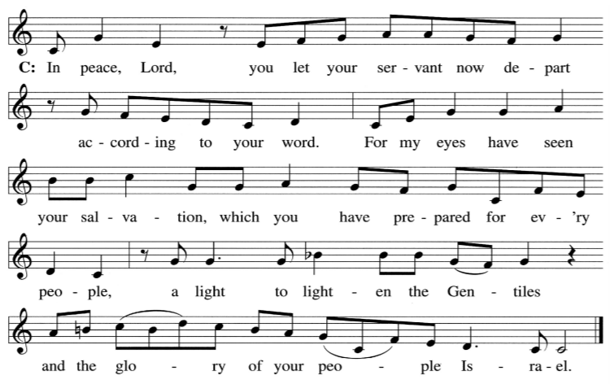
BLESSING
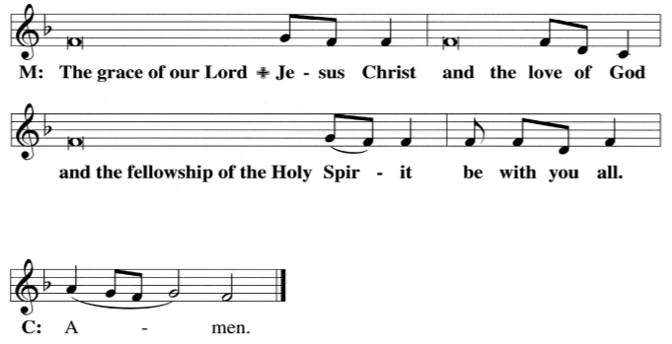
CLOSING HYMN Now Rest beneath Night’s Shadow | CW 587
WORSHIP THEME:
This Lent, we will use the metaphor of eyesight to examine how the various people in Mark’s Gospel viewed Jesus during His Passion. In most cases, they misunderstood who He was and what He was doing; then again, sometimes by faith people did recognize Him correctly.
We have these forty days of Lent in which we may look within ourselves as people of faith in our day. How are we like or unlike the people who saw Jesus in the flesh? Most important, as we gather for worship, we will see what Jesus has done to save us from our sins by His holy, precious blood and innocent sufferings and death.
Tonight, we see in Gethsemane that Jesus’ inner circle—Peter, James, and John—cannot keep their eyes open to watch and pray with Him for even an hour. How awake have we been, lest we fall prey to temptation? Why does Jesus agree that His Father’s will be done?
Lent 2
Sleepy Eyes
Mark 14:32-42
Lent 3
Denying Eyes
Mark 14:26-31,66-72
Lent 4
Murderous Eyes
Mark 14:1-2, 53-65
Lent 5
Worldly Eyes
Mark 15:1-20
Holy Thursday
More Than Meets the Eye
Mark 14:22-25
Good Friday
God’s Eyes
Mark 15:21-39

Easter Vigil
Resting Eyes
Mark 15:40-16:1
Easter
Angel Eyes
Mark 16:1-8

13009 N. Elderberry Ct.
Lodi, CA 95242
www.christlodi.org
209-368-6250
Pastor Joshua Hanson

